C.Hirani

P.Manickwatta

2nd Division,

Dickoya

25/11/2015.

The Manager,

Dear Sir/ Madam,

**Request for a JOB VACANCIES.**

Here I certify that I am a Completed A/L Examination In 2013. I am following Chartered Accountancy in The institute of Chartered Accountants in Sri Lanka (Executive Level)

I like to get a Working from your company in this relevant field.

I hereby draw your kind attention to the matter and like to request you to see the possibility of obtaining a placement for Working at your company.

Here I attached my curriculum vitae with this letter. I should glad if you would give this matter your consideration.

Thank you.

Your faithfully

C.Hirani

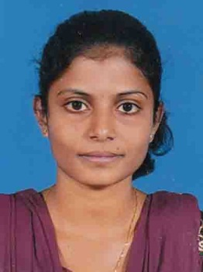

**Chanrakumar Hirani,**

**02nd Divition,**

**Dickoya**.

**Mobile: 077 0240887**

**E-mail**: Hirani22.hc@gmail.com

**PERSONAL PROFILE**

I am self - motivated, energetic, flexible person and always willing to do continuous learning. I have good team working and leadership skills, which I have achieved through my extracurricular activities and academic work. I can communicate in English, Tamil and Sinhala Languages.

**ACADEMIC QUALIFICATION**

**\*Passed G.C.E Ordinary Level Examination- (Tamil Medium) 2010**

|  |  |
| --- | --- |
| Subjects | Grade |
| Mathematics | B |
| Health & Physical | A |
| Saivanery | A |
| English | C |
| Tami (Literature) | A |
| Tamil Language | A |
| Civics | A |
| Science | C |
| History | C |
|  |  |

**\*Passed G.C.E Advanced Level Examination- (Commerce Steam) (Tamil Medium) 2013**

|  |  |
| --- | --- |
| Subjects | Grade |
| Economics | B |
| Business Studies | C |
| Accounting | A |

**PROFESSIONAL QUALIFICATION**

* Reading Executive Level of The institute of Chartered Accountants of Sri Lanka.
* Successfully Completed MS office (word, Excel, Access, PowerPoint )
* Passed The 2 Levels of AAT Accountants of Sri Lanka (Foundation , Intermediate )
* Fluency in Writing and speaking in Tamil, Sinhala & English

**SKILLS**

* Ability of working with team spirit
* Ability to meet deadlines promptly

**EXTRA CURRICULAR ACTIVITIES**

* Committee Member of School Productivity Monitoring Unit
* Committee Member of School Students Consumer Circle
* I have first place for English recitation

**PERSONAL INFORMATION**

Name with initials : C.Hirani

Name in Full : Chandrakumar Hirani

Date of Birth : 22rd of November 1994

Age : 21 years

Sex : Female

Marital Status : Single

NIC No : 948274213V

Religion : Hinduism

Schools Attended : N/Highlands Central College

Hatton

**ATTESTATION**

1. Name of the Attester Mr.S.N.Croozs

Principal of

St.John Bosco’s College

Hatton

2. Name of the Attester Mrs. D. M. S. Nisansala

English Teacher of Laxapana College

I do hereby certify that the above mentioned information are true and correct to the best of my

Knowledge, and given the opportunity I would strive hard to exceed your expectations.

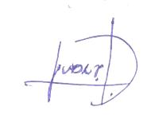

……………….........

Date: 25.11.2015 C.Hirani